WORKING LANDS AND CONSERVATION

COMMUNITY MEETING

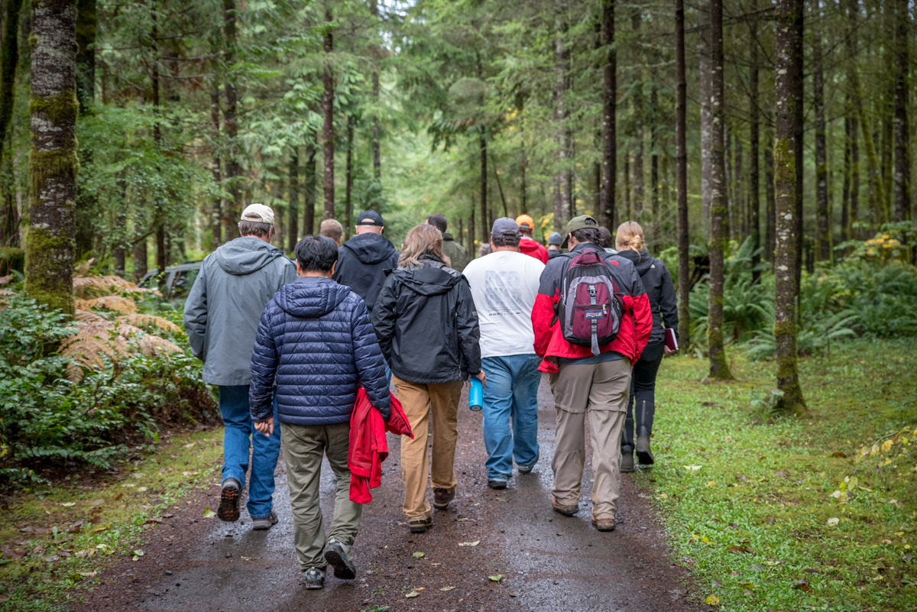
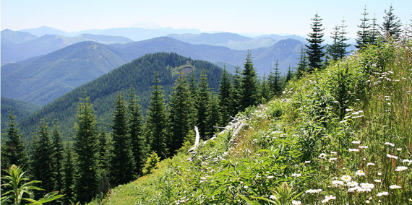
1–2 NOVEMBER 2018
TABLE OF CONTENTS
Executive Summary 3
Presentations 4
Keynote Speaker 4
Introduction to Landscape Conservation Design 6
The Values and Benefits of Collaborative Conservation 6
Panel Presentations 8
Large Forest Landowner Panel 9
Small Forest Landowner Panel 12
Agriculture Panel 15
Conservation Panel 16
Agency Panel 19
Crosswalk of Panel Input 23
Breakout Sessions 26
Near-term challenges and stressors 26
Communication/People 26
Land ownership/management 26
Funding 27
Regulations 27
Infrastructure 27
Conservation Issues 27
Long-term challenges and stressors 28
People 28
Climate Change Effects 28
Land-related 28
Funding, Markets, and Infrastructure 28
Conservation 29
Solutions That Address Near-Term Challenges 29
Solutions That Address Long-Term Challenges 30
List of Attendees (workshop and field trip) 32

Executive Summary
The Pacific Northwest Coast Landscape Conservation Design (LCD) partnership hosted a two-day event in Chehalis, Washington focused on working landscapes in Southwest Washington. A diverse collection of community members and stakeholders gathered here to learn more about working lands and to foster a better understanding of their individual and collective values. Discussions focused on finding ways to keep working lands working while maintaining connected and healthy ecosystems.
The goals of the workshop were to identify: 1) strongly held conservation and land use values of community members and stakeholders in Southwest Washington, 2) challenges to maintaining working lands and wildlife in Southwest Washington, and 3) potential strategies to maintain and support working lands and local economies while advancing wildlife conservation in this region.
The event began on November 1 with Ken and Bonnie Miller hosting a field trip on their family tree farm adjacent to Millersylvania State Park south of Olympia. About 30 people went on this walking tour to learn about the Millers’ forest operations as well as the challenges they face running a working forest. Participants also learned about a host of conservation incentives available to small forest landowners.
On November 2, about 70 people representing large and small forest landowners, farm producers, conservation organizations, tribes, academic institutions, and agencies convened for a “Working Lands and Conservation Community Meeting.” Participants learned about the values that different stakeholders and members of the community hold for working lands in the region. They also learned of the challenges to achieving sustainable working lands, local economies, and wildlife populations, as well as strategies to balance all those values. Lisa DeBruyckere of Creative Resource Strategies, LLC facilitated the meeting.
Three speakers set the stage for the meeting by emphasizing the need for strong rural economies while conserving native fish and wildlife habitat. They also talked about the evolution of the LCD, the importance of conservation planning and landscape connectivity, and the purpose of using collaborative landscape conservation to sustain the values of people living and working in the region. Groups of panelists representing large and small forest landowners, agricultural producers, state and federal agencies, and conservation organizations then shared their perspectives with respect to their values, goals, and the challenges they face in managing and conserving working lands. They also shared ideas for overcoming the challenges to managing land in Southwest Washington.
Participants then formed breakout groups to share perspectives of what they heard from the panelists. Each breakout group identified their individual challenges, as well as strategies, tools, and programs to address them. The event concluded with a rundown of the highlights from the meeting as well as key next steps, including plans to follow up on this workshop to see where we can begin tackling some of the challenges we heard.

Presentations

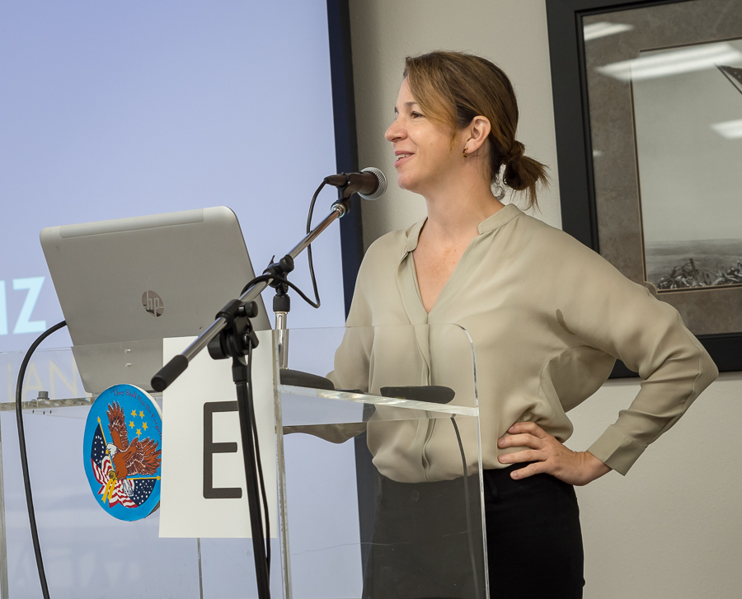
Keynote Speaker
Figure 1. Keynote speaker Hilary Franz, Commissioner of Public Lands. Photo credit: John Mankowski.
Hilary Franz, Washington State Commissioner of Public Lands, was the Working Lands and Conservation Community Meeting keynote speaker. In her talk, she spoke of how communities in Southwest Washington are on the front lines of a rapidly changing landscape. She emphasized an All Hands, All Lands approach to overcoming the challenges that poses on the local community. The foundation of this approach is collaboration to achieve shared goals.
Commissioner Franz described challenges rural Southwest Washington communities face, such as increased risk of wildfire. She spoke of the need to balance interests by owning one another’s problems and stepping outside our individual focuses, so we can cooperatively look for ways to make rural communities livable and sustainable while providing for the needs of native fish and wildlife.
Commissioner Franz noted that rural communities are at the forefront of significant environmental issues, such as floods, ocean acidification, drought, and reduced soil nutrition. She described new approaches in Washington to address environmental challenges, such as a program that recovers derelict vessels while creating jobs and stimulating local economies.
Commissioner Franz emphasized the importance of addressing connectivity in the lands we manage, noting that we need true connectivity (i.e., interrelationship between connected people and connected habitats) to make environmental stewardship and economic opportunity a reality for rural communities.
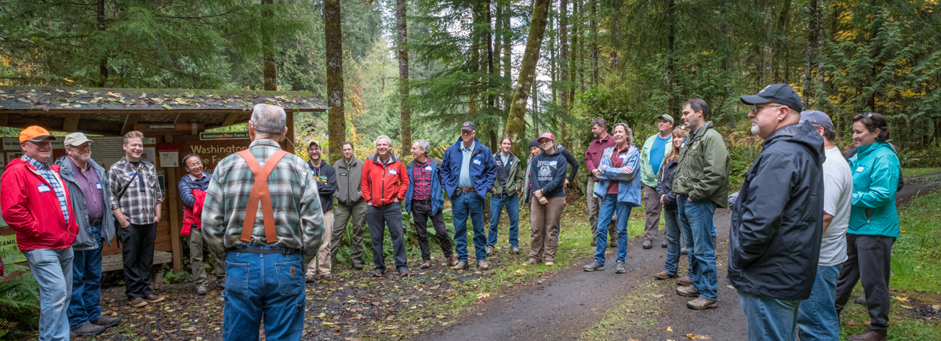
Figure 2. Ken Miller sharing his thoughts and perspectives about managing his family tree farm. Photo credit: John Mankowski.

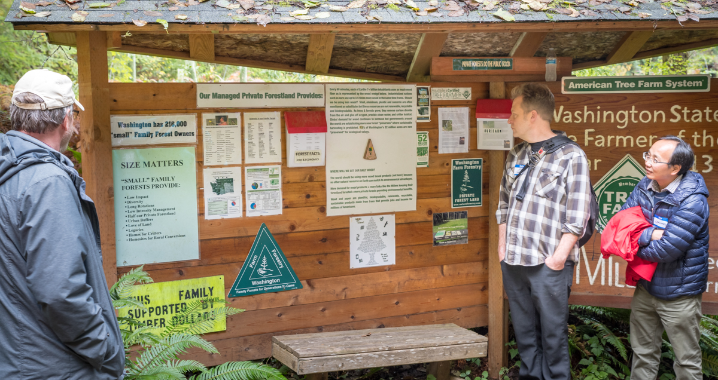
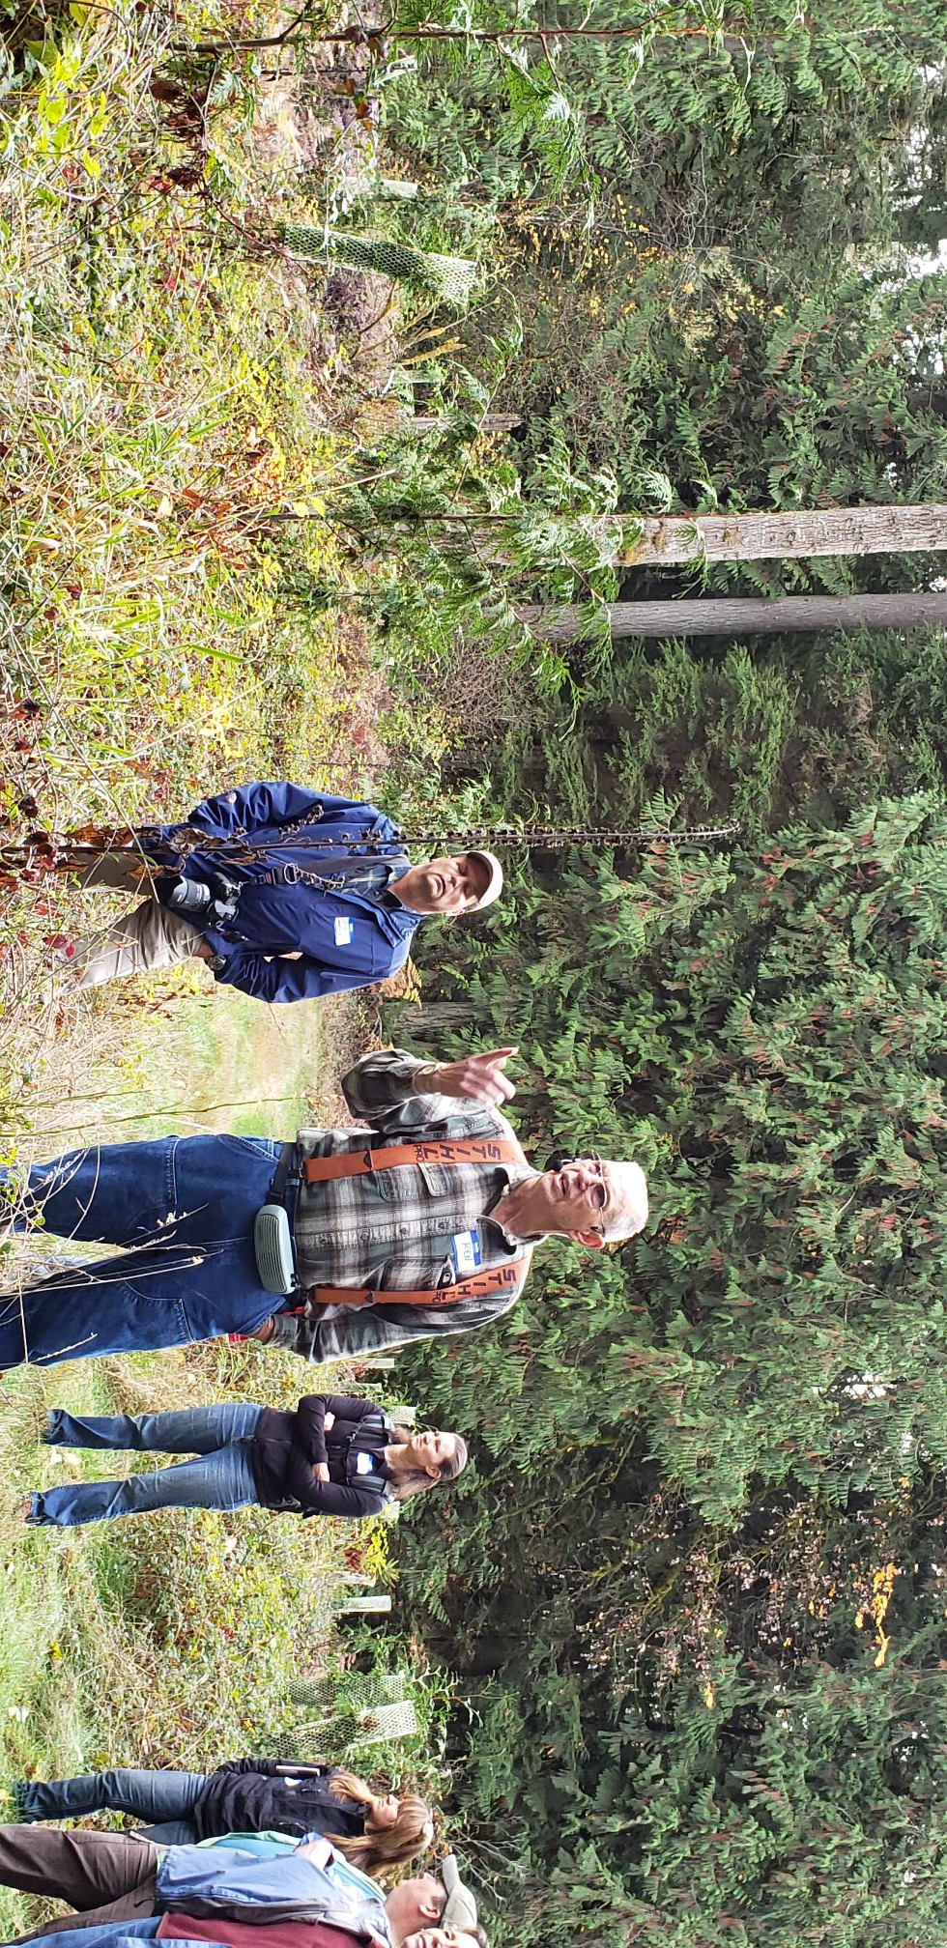
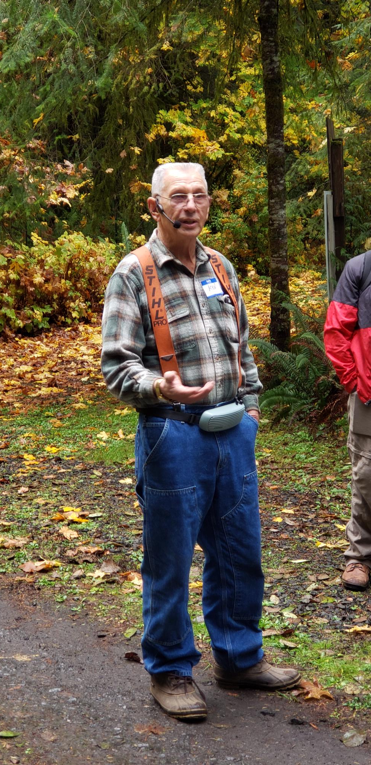
Figure 3. Left photo: Ken Miller hosting a tour of his tree farm with workshop participants on November 1. Photo credit: Lisa DeBruyckere.

Figure 4. Middle photo: Workshop participants absorbing the challenges and opportunities of managing small woodlands in southwest Washington. Photo credit: Lisa DeBruyckere.
Figure 5. Below photo: Workshop participants reviewing information about Ken and Bonnie Miller’s tree farm. Photo credit: John Mankowski.

Introduction to Landscape Conservation Design
Tom Miewald of the US Fish and Wildlife Service introduced participants to the principles of landscape conservation design followed by an overview of the LCD project. He discussed that the project encompasses the entire Pacific Temperate Rainforest ecoregion, but we are convening groups at sub-regional scales, such as Southwest Washington in order to make grassroots perspectives a central part of this project. He noted the project’s origin in the National Wildlife Refuge System, where refuge managers wanted a better understanding of their role in the broader landscape. Through dialogue with partners, we found this is a common question. Tom noted that addressing the problems tied to changing landscapes is not simple and thus require multi-stakeholder solutions.
Tom showed a series of satellite images illustrating 40 years of landscape change in Southwest Washington. This landscape has seen significant transformation, and we anticipate more change with the region’s population still on the rise along with climate change impacts. This project looks ahead to characterize conservation and natural resources in the region, through collaborative, community-based strategies to maintain a sustainable landscape for people and wildlife. Tom noted that a top-down approach would not be successful. Rather, we need broad collaboration and shared resources to meet common goals. Tom showed the results of a Social Network Analysis to illustrate the current collaborative connections among local partners in this region.

The Values and Benefits of Collaborative Conservation
John Mankowski of Mankowski Environmental Consulting discussed the policy aspects of the rapidly growing practice of using collaborative landscape conservation to sustain the multiple values we place on working lands. Mankowski recognized the important work going on to conserve this landscape. He also emphasized a need to understand how this work fits into a broader landscape context. In adopting a landscape conservation approach, we need to look further ahead, e.g., 50 years, and be inclusive when engaging our local partners. Mankowski emphasized collective impact and collaboratively working across geographic and political boundaries, which typically achieves greater conservation outcomes than organizations operating independently. Collaborative conservation moves people past the false “nature versus people” dichotomy to consider entire landscapes capable of achieving ecological, cultural, and economic benefits. Mankowski noted the elements of collaborative conservation, including a defined geography (e.g., Southwest Washington), developing a shared vision and goals, collaborative planning, on-the-ground implementation, as well as strategies to adapt through time.
Mankowski pointed to the common challenges to landscape conservation in general, including a lack of capacity/skills/communication, meeting/collaboration fatigue, and difficulty measuring/demonstrating success. He also noted the challenges of managing working lands in a fast growing region with considerable pressure to develop. Though these challenges are real, Mankowski pointed to signs of tremendous opportunity in Southwest Washington. Specifically he pointed to the many partners engaged in efforts to sustain working lands for conservation and healthy local economies. Partnered together he said these stakeholders have tremendous potential to share ideas and resources to work towards mutually beneficial outcomes.

Panel Presentations
Panelists representing large forestry, small family foresters, agriculture, the conservation community, and agencies gave short presentations responding to the following questions:

- What values do you strongly hold for conservation and land management in Southwest Washington?
- How is land use, resource management, and/or conservation important to the quality of life in Southwest Washington?
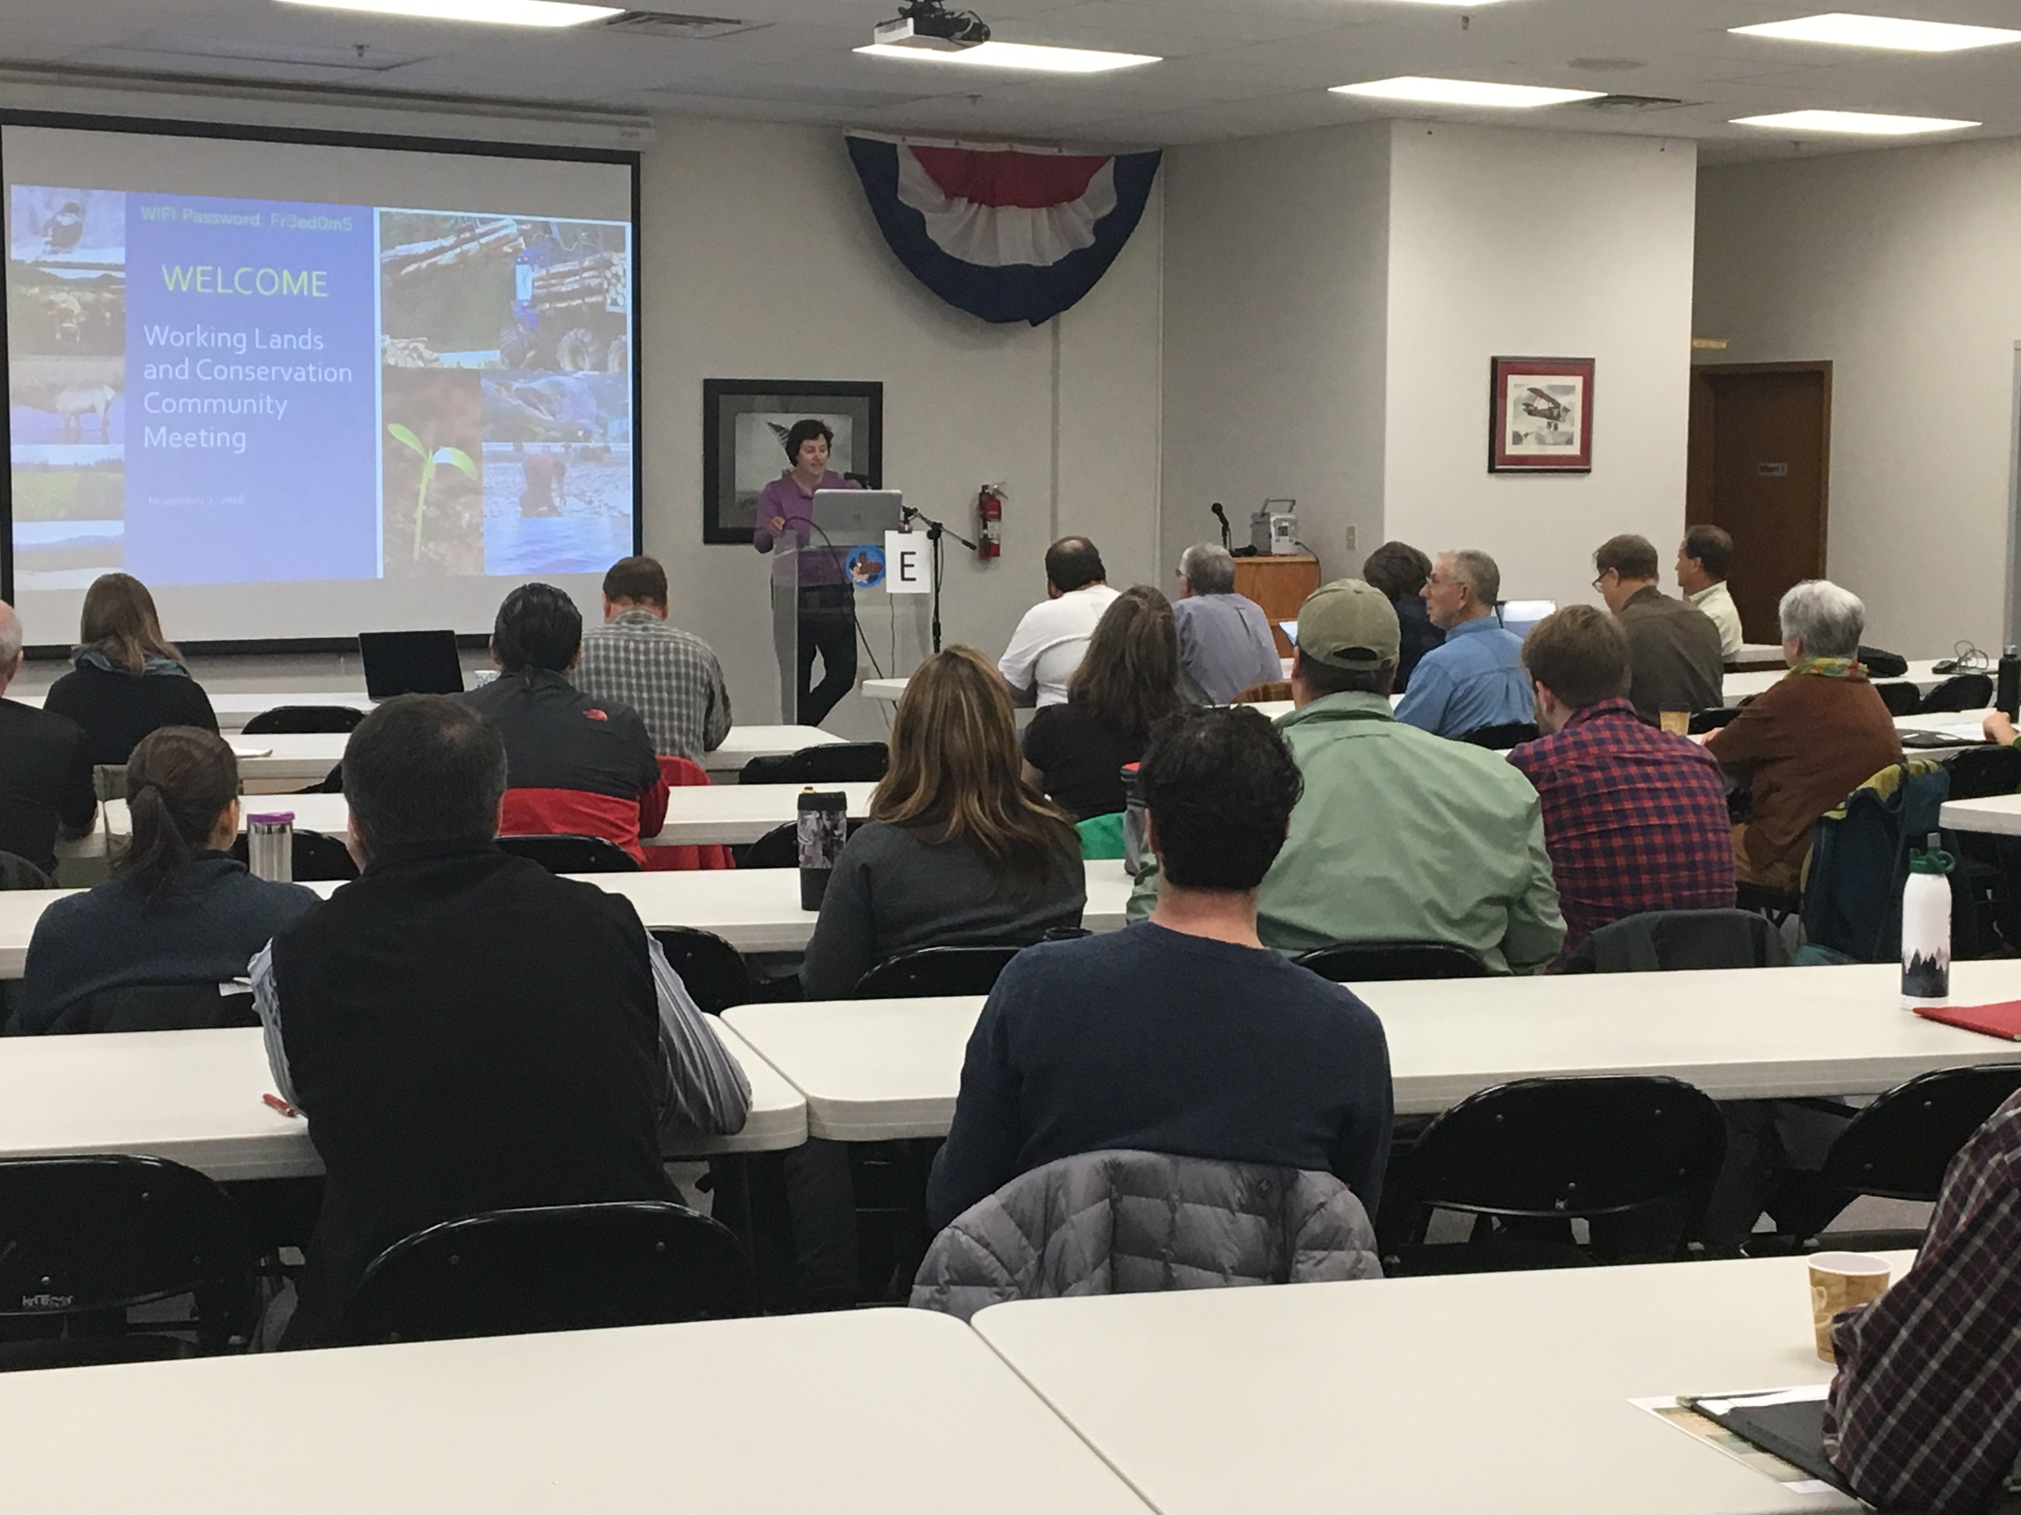
- What do you see as your primary goals and objectives in managing and conserving land in Southwest Washington? (near term and 50-year outlook)
Figure 6. Community meeting participants preparing to roll up their sleeves and work collaboratively to develop a shared understanding of goals and values, and seek creative solutions. Photo credit: Robb Krehbiel.
- What are big impediments to managing and/or conserving land in Southwest Washington? (near term and 50-year outlook)
- Do you have ideas or suggestions for how to overcome these impediments, particularly through collaborative engagement among stakeholders?
- Is there anything else you would like to add?

The following facilitators convened each of the panels before the community meeting to develop responses to each of the panel questions:

- Large forest landowners—John Mankowski, Mankowski Environmental Consulting
- Small forest landowners—John Mankowski, Mankowski Environmental Consulting
- Agriculture representatives—Lenny Young, Washington State Department of Natural Resources
- Conservation representatives—Robb Krehbiel, Defenders of Wildlife
- Agency representatives—Jeff Azerrad, Washington Department of Fish and Wildlife

Large Forest Landowner Panel
Court Stanley—President of United States and New Zealand Forestry, Port Blakely
Kevin Godbout—Director of External and Regulatory Affairs, Weyerhaeuser Company
Eric Schallon—Forestry Operations Manager, Green Diamond Resource Company
Adrian Miller—Director of Administration and Corporate Affairs, Pope Resources
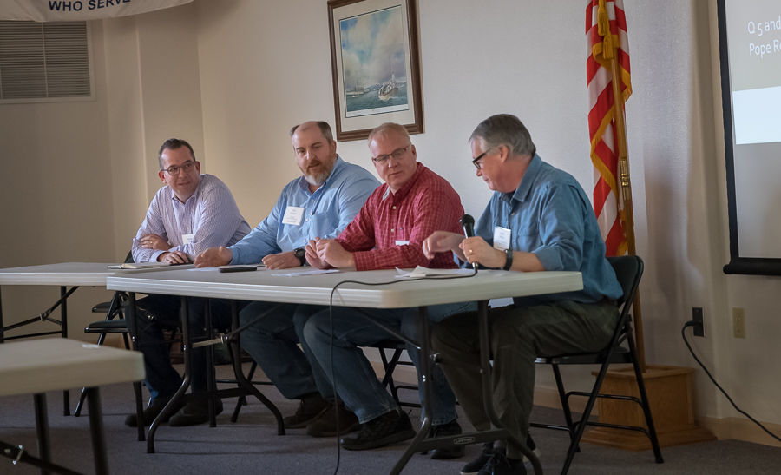
Figure 7. Large forest landowners share their perspectives with meeting attendees. Photo credit: John Mankowski.
1. What values do you strongly hold for conservation and land management in Southwest Washington?
- Working forests and conservation can work well together to provide many benefits for the environment, wildlife, and the people.
- Manage for the long-term sustainability of the forests, providing fiber for generations as well as habitat for the species that live in our forests.
- The future truly matters to large landowners as they are in the land management business for the long term.
- We own and manage forests for long-term economic, social, and conservation benefits, while recognizing the strong relationship with the natural world and the communities in which we work and live.
- Stewardship is a widely held core value, realized through disciplined and resourceful management and measured by our sustainable growth, both in terms of our business and through forestry practices.
- Strong forest and wood products markets (domestic and international) ensure a healthy environment and sustain rural economies.

2. How is land use, resource management, and/or conservation important to the quality of life in Southwest Washington?
- Conservation and land management are inextricably intertwined, in both Southwest Washington as well as other lands we manage.
- Working forests and conservation can work well together to provide many benefits for the environment, wildlife, and the people.
- Manage for the long-term sustainability of the forests, providing fiber for generations as well as habitat for the species that live in our forests.
- The future truly matters to large landowners as they are in the land management business for the long term.
- Owning and managing forests for long term economic, social and conservation benefits, while recognizing that the strong relationship with the natural world and the communities in which we work and live.
- Stewardship is a widely held core value, realized through disciplined and resourceful management and measured by our sustainable growth, both in terms of our business and through forestry practices.
- Strong forest and wood products markets (domestic and international) ensure a healthy environment and sustain rural economies.
3. What do you see as your primary goals and objectives in managing and conserving land in Southwest Washington?
- Keeping our working forestlands economically viable while providing the environmental benefits within the forest practice laws.
- Making strong connections between working forests and benefits to society and the environment.
- Getting to a place where our forests are recognized for the social, environmental, and economic benefits they provide, and those benefits are valued so that forestry is preferred over other land uses.
- Seeking regulatory stability.
- Building and maintaining an educated and trained workforce.
- Supporting infrastructure capacity and capital improvements needed to support domestic and international markets.
- Growing ownership in Southwest Washington with a goal of sustainably managing our forests and supplying logs to customers.
- Seeking opportunities to diversify income streams through the sale of development rights and, in some cases, thoughtful development, which is made more attractive by the proximity of our managed forest lands.
- Seeking new opportunities for providing value from forest lands including energy production (wind, solar, geothermal).
- Ensuring that policy makers and influencers recognize the relationship between strong markets and a healthy environment and rural economy.
4. What are big impediments to managing and/or conserving land in Southwest Washington?
- Lack of community and institutional awareness of forest management practices and the benefits working forest provide to water, wildlife, and carbon storage.
- Population increases and continued pressure for conversion /development to accommodate growth.
- Threats from increased regulations (and regulatory complexity), instead of incentives.
- Overly restrictive zoning and appraisal issues.
- Improvements are needed to increase coordination and effectiveness of forest regulatory programs (e.g., agencies and tribal oversight processes).
- Short-term political shifts in working environment, based on an urban populace unfamiliar with natural resource systems.
- Litigation-driven agendas by some in the agencies, tribes, and the environmental community – making it difficult to find collaborative opportunities that advance joint priorities.
- Lack of significant public funds to “buy/pay” for ecosystem services.
- Risk that comes from buffers becoming habitat for other listed species.
- Longer-term uncertainties associated with climate change and changing social norms.
5. Do you have ideas or suggestions for how to overcome these impediments, particularly through collaborative engagement among stakeholders?
- Build the relationships and trust with all the stakeholders and seek opportunities to work together and to work on bigger-picture risks facing the region.
- Increase social license to operate by collective messaging developed collaboratively among conservation, timber, and agricultural communities to better inform the public about the importance of forest and farmland management.
- Build a coalition that focuses on landscape-scale issues and seeks collaborative strategies to work together to keep the region’s multiple-benefits intact.
- Big-picture collaboration is difficult when entities are fighting over small-scale issues.
- Expand, improve, and build flexibility into programs such as the Forest Legacy Program that provide landowners incentives to maintain the land in forestry while being compensated for the development value of their property.
- Educate policy makers and consumers about the positive carbon sequestration benefit of wood as a building material.
- Seek opportunities for increased flexibility in land use regulations.
- Rebranding the “logger” as a highly skilled profession.
- Improve design and use of mechanisms that protect landowners from ESA risk as they grow habitat for ESA-listed species.
- Promote broader understanding and support for the relationship between strong domestic and international markets, environmental benefits, and sustainable communities.
6. Is there anything else panel members would like to add?
- More recently, organizations that used to be adversarial are learning that they share many common goals.
- This change in perception has the potential to facilitate advancements in landscape-scale efforts to keep Southwest Washington healthy and productive for future generations.
- A good example where divergent interests have achieved collaboration is the emerging forest collaborative process in the Inter-mountain West to address forest health/fuel management. Those types of processes can address divergent viewpoints and limit litigation/bureaucracy; however, they generally lack scale-level effects and are not economically sustainable without government assistance.

Small Forest Landowner Panel
Ken Miller—Tree farm owner in Grays Harbor and Thurston counties, active in SFLO policy development and awarded Tree Farmer of the Year in 2013
John Henrikson—Owner of Wild Thyme Farm in Oakville, Washington , uses mix of agriculture and forestry to create sustainable business model
Andrea Watts—Manages family tree farm near McCleary, Washington. Combines academic background, education interests, and practical experience to manage 3rd generation tree farm
Elaine Oneil—Executive Director of Washington Farm Forestry Association
Luke Rogers—University of Washington Researcher
Patrick Shults—Southwest Washington Extension Forester
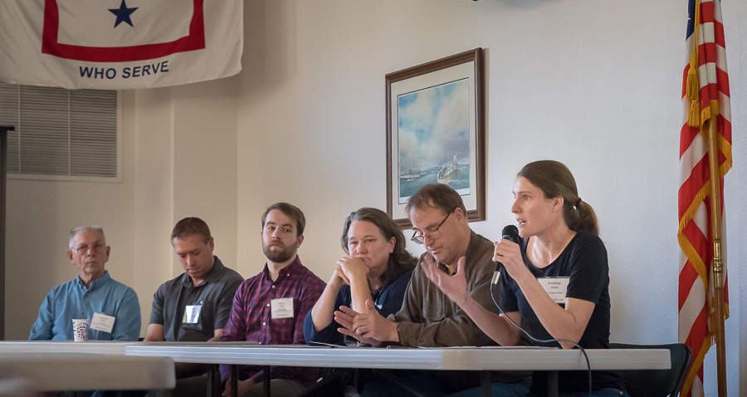
1. What values do you strongly hold for conservation and land management in Southwest Washington?
- Keeping forestlands forested – Well-managed forests are a preferred land use for environmental and species benefits compared to development or conversion.
- The region’s diverse mosaic of working conservation lands where good stewardship also provides high quality habitat.
Figure 8. Small forest landowners describe the values and goals of managing small woodlands. Photo credit: John Mankowski.
- Small forest landowners strive to be good stewards.
- The potential exists for forest landowners and the conservation community to strengthen collaboration.
- Small forest landowners love growing trees, but it also needs to be financially viable.

2. How is land use, resource management, and/or conservation important to the quality of life in Southwest Washington?
- The region is very productive – good soils, moisture, access to markets – which provides good conditions for growing trees - and capacity to support habitat for wildlife and fish.
- Timber, forest products, shellfish, fishing, and agriculture all contribute to quality of life in Southwest Washington.
- Rural economies are supported by working forests.
- Quality of life is enhanced by a history of inter-generational family tree farms.
- Well-managed tree farms also contribute to other quality-of-life values, including scenic viewscapes, outdoor recreation, fish and wildlife habitat, clean water, outdoor education, carbon storage, etc.

3. What do you see as your primary goals and objectives in managing and conserving land in Southwest Washington?
- Forest management goals vary from owner to owner, including: leaving a legacy for future generations, healthy and diverse fish and wildlife habitat, economic returns, independent lifestyle, and a peaceful and healthy retirement setting.
- Objectives often depend on the condition of the land and individual stands, but can include moving overstocked unhealthy stands to better conditions, creating mixed age classes across the landscape, planning for desired future conditions for economic and non-economic purposes, and contributing to the mix of conservation and managed lands important to the region.
- Finding ways to make owning and managing family forest tree farms financially viable, so we can attract others to do it, and continue the legacy of ecosystem services of these lands into the future.
- Some goals include research and advancing the science of sustainable and economically viable forest management.
- Education – teaching the public about forest management, what is involved, and the benefits that are provided (water, habitat, wood, open space, income, jobs) in the hopes of maintaining social license to operate and continue the legacy of small forest landowner stewardship in future generations.
4. What are big impediments to managing and/or conserving land in Southwest Washington?
- General lack of respect and appreciation for small forest owners and forest managers.
- Barriers to inter-generational transfer of lands, skills, and desire to continue managing working tree farms.
- Ever-increasing regulatory burdens and complexity – disproportionate impact on small forest landowners.
- Lack of social license to conduct active tree farm activities.
- Potential future lack of infrastructure to deal with large diameter trees.
- Lack of sufficient and simple non-timber revenue streams.
- Unkept promises from the Forest and Fish Habitat Conservation Plan:
1) Forest Riparian Easement Program (FREP)
funding
2) Small Forest Landowner Office for adequate technical assistance
3) Alternate harvest rules for smaller harvests
- The high quality of life provided by these rural landscapes can bring too much attention – double edged sword – being loved to death!
- Increased pressure from adjacent land uses, such as development and sub-divisions
5. Do you have ideas or suggestions for how to overcome these impediments, particularly through collaborative engagement among stakeholders?
Respect
- Increase public understand and respect for small forest landowners, the work they do, and the benefits they provide.
- Find ways for agency staff and conservation community to become better partners with small forest landowners. Agency/societal goals will be hard/impossible to achieve if small forest landowners convert lands because they feel disrespected/unappreciated.
- Seek opportunities for joint positive messaging – increase the social license to operate.
- Need to make it more attractive for people to be willing to own and manage forest lands – increase timber and non-timber revenue options.

Incentives
- Expand use of purchase or transfer of development rights, to provide economic return to small forest landowners and retain functional blocks of working forests.
- Improve funding, utility, and focus of easement and incentive programs.
- Carbon offset programs – seem to have limited potential so far, high legal fees, administrative costs, and complexity.
- Expand landowner education and technical support to enhance stewardship of small forest landowner lands.
Regulations
- Agencies, conservation community, and the public need to understand financial burdens that come with growing/protecting certain habitat conditions – can we look for ways to help pay for this? Smarter buffers?
- Additional regulations can lead to costs and reduced desire of future generations to continue our legacy of good stewardship.
- When regulations cause landowners to convert lands to other uses, many environmental benefits are lost.
6. Is there anything else panel members would like to add?
- Retain current land use taxation system; encourages long-term forest management.
- Caution against ‘Public benefits’ that come from owning forest land being annexed away from the landowner’s opportunity to create private benefits.

Agriculture Panel
Jay Gordon—Policy Director, Washington State Dairy Federation
Colin Barricklow—Owner/Farmer, Kirsop Farm
Fred Colvin—Owner/Rancher, Colvin Ranch
Bill Dewey—Director of Public Affairs, Taylor Shellfish Farms
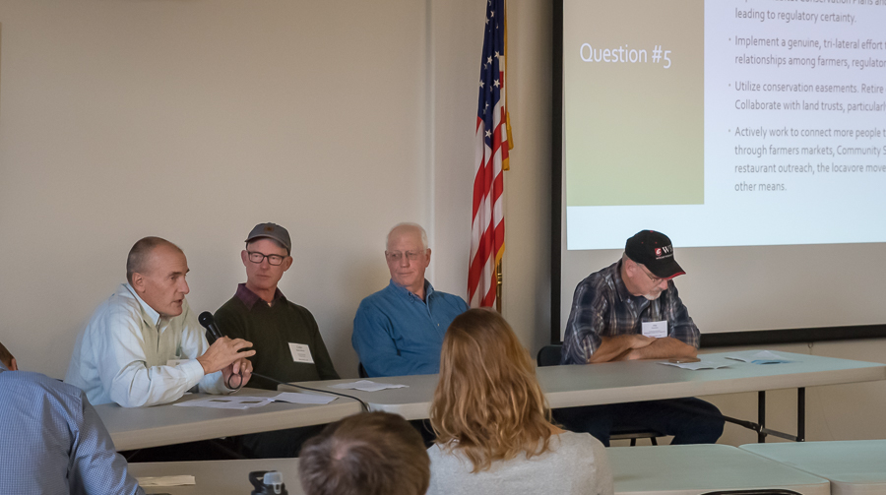
Figure 9. A diverse agriculture panel, including representatives from ranching, shellfish growing, local farms, and commercial dairy farms collectively described their challenges and opportunities. Photo credit: John Mankowski.
1. What values do you strongly hold for conservation and land management in Southwest Washington?
- We are farmers. We work the land.
- We take a multi-generation perspective.
- We share a bias toward working lands. By definition, working lands must remain economically viable.
- We have a strong land conservation ethic. This is part of our heritage and how we derive our livelihood.
- We seek the right balance between working lands and species conservation. Done right, this doesn’t have to be an “either/or.”
- Southwest Washington is a resource-based economy. Preserving working lands is important; maintaining land functionality is important.
2. How is land use, resource management, and/or conservation important to the quality of life in Southwest Washington?
- Southwest Washington is a natural resource-based economy: crops, dairy, cattle, shellfish, fishing, and timber. The region’s communities depend on natural resources. There are no Boeings or Microsofts.
- Southwest Washington’s rural quality of life is why people live here, managing for future generations.
- Many who drive through or recreate in Southwest Washington do not realize the vital connections among the people who live here, their livelihood and way of life, and the region’s natural resources.
3. What do you see as your primary goals and objectives in managing and conserving land in Southwest Washington?
- Do the best possible job of farming the land. Meet both financial and conservation goals.
- Prepare for passing our farms, intact and prosperous, to the next generation. Encourage young people to choose to get into agriculture at the age of 16–18. Help interested farm workers transition into farm owners.
- Maintain water rights and water quality. Water will be increasingly important in a climate change future.
- Obtain regulatory certainty. Develop credible, self-directed farm plans that provide meaningful conservation outcomes instead of just complying with the rules.
- Improve agricultural markets, networks, and communications.
4. What are big impediments to managing and/or conserving land in Southwest Washington?
- An apparent lack of concern for the welfare of farmers. Regulators and non-governmental organizations need to be just as concerned about farmers as they are about animal species.
- Lack of regulatory certainty. Increasingly burdensome regulations are causing some farmers to fold and sell out. Regulators and non-governmental organizations need to recognize that working lands must remain profitable while meeting conservation goals.
- Distrustful regulatory relationships. Litigation in the regulatory environment.
- Development, conversion of agricultural land. Zoning must support farming.
- Social resistance to controlling harmful pests.
- Climate change. Changes in ocean chemistry.
5. Do you have ideas or suggestions for how to overcome these impediments, particularly through collaborative engagement among stakeholders?
- Explore Habitat Conservation Plans and other mechanisms leading to regulatory certainty.
- Implement a genuine, tri-lateral effort to improve trust relationships among farmers, regulators, and non-governmental organizations.
- Utilize conservation easements. Retire development rights. Collaborate with land trusts, particularly farmland trusts.
- Actively work to connect more people to farmers and farming through farmers markets, Community Supported Agriculture, restaurant outreach, the locavore movement, ecotourism, and other means.
6. Is there anything else panel members would like to add?
- We hope for a bright future. There are opportunities to enhance both farming and conservation in Southwest Washington.
- Society must recognize the human aspect of farming. Concern can’t be just about animal species. It must also be about people, working lands, and a reasonable regulatory environment. Society must recognize that farmers are part of the equation.
- We need others to understand and trust us. Farmers must be good stewards to make a living and must make a living to be good stewards. We want to be great stewards. We need the trust and the tools to do right and survive.

Conservation Panel
“We need innovative approaches to commit to long-term conservation. We need to commit to working together in unison.”
~ Agency panel representative
“Stewardship is leaving lands better than we found them. Stewardship also pertains to the communities – our lands surround small towns, and we have a responsibility to provide jobs and help with education.”
~ Industrial forest landowner panel representative
“We will succeed toward our shared and separate goals where we spend time together and dwell on commonly held values—communities, clean water, clean air, generational forestry, public access, fish and wildlife, and functioning ecosystems.”
~ Conservation panel representative
Nicholas Carr—Forterra
Paula Swedeen—Conservation Northwest
Robb Krehbiel—Defenders of Wildlife
Kelly McAllister—Habitat Connectivity Working Group and Washington Department of Transportation

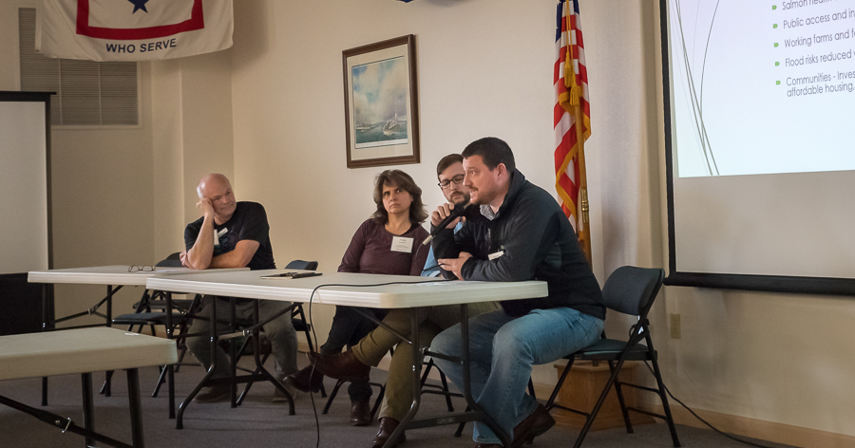
1. What values do you strongly hold for conservation and land management in Southwest Washington?
- Balanced economic growth with conservation and forestry.
- Old and structurally diverse forests.
- Voluntary, non-regulatory approaches to conservation.
Figure 10. The conservation panel shared a list of "common ground" items they believed were shared by each of the panels. Photo credit: John Mankowski.
- Community forestry.
- Salmon health and habitat – protecting riparian and upland ecosystems.
- Public access and increased recreational opportunities.
- Working farms and forests protected from conversion.
- Flood risks reduced without impacting sensitive species.
- Communities - Invest in quality of life that supports our natural resources, but offers stable affordable housing, diverse economic opportunities, and sustainable growth.

2. How is land use, resource management, and/or conservation important to the quality of life in Southwest Washington?
- Natural resource economies are vital to the region: forestry, fishing, and agriculture.
- Small communities and rural values support public access, wildlife conservation, and working lands.
- Hunting and fishing are important, so it is essential to maintain resilient populations.
- Salmon are valued for recreational, commercial, and tribal fisheries.
- Salmon are culturally vital to Native Americans and Tribes in the region.
- Productive, fast-growing forests means there is very high carbon sequestration potential. The region is important to meet statewide carbon-reduction goals and should get financial investments.

3. What do you see as your primary goals and objectives in managing and conserving land in Southwest Washington?
- Near term and 50-year outlook
  - Varied management across the landscape that includes active forest management, and growth of old forest stands.
  - Low road densities.
  - Non-regulatory, voluntary (transactional) conservation strategies with private landowners.
  - Varied forestry practices, including longer rotations and prescriptions that sequester more carbon, provide better habitat, and prevent watershed degradation.
  - Conservation strategies with multiple benefits that engage local communities and tribes and are on a large, watershed scale.
  - Permeable I-5 to allow for greater wildlife movement.
  - Fish passage barrier removal.
  - Land and water for recreation and wildlife.
  - Thriving diverse wildlife including threatened and endangered species.
4. What are big impediments to managing and/or conserving land in Southwest Washington?
- Near term and 50-year outlook
  - Timber ownership patterns – timber investment and real estate models to buy, sell, and develop.
  - Funding to support voluntary forestry and conservation strategies that benefit fish and wildlife habitat.
  - Permanent land protection to support infrastructure projects, e.g., habitat highway crossings and flood retention projects.
  - Development pressure along I-5 limits open space and habitat protection.
  - Climate change affecting flooding, invasive species, and habitat.
  - Stewardship and land management must keep pace with conservation.
  - Isolated wildlife populations in the region are severely impacted by disease (such as hoof disease in elk).
  - Distrust among community and leaders about conservation goals.
5. Do you have ideas or suggestions for how to overcome these impediments, particularly through collaborative engagement among stakeholders?
- Common ground – Focus on developing diverse support for funding and projects.
- Community forests – Build support for community forests that have local ownership, provide revenue, water quality protection, public access, and habitat.
- Wildlife crossings – Identify appropriate places and support for wildlife to cross highways.
- Voluntary conservation – Pursue transactional, non-regulatory conservation actions to support private, working lands.
- Stewardship endowment – Develop strategies that focus on stewardship and explore public support for stewardship endowment.
- Flood-risk mitigation – Protect communities without impacting wildlife.
6. Additional Perspectives

Common Ground
- We will succeed toward our shared and separate goals where we spend time together and dwell on commonly held values.
  - Communities
  - Clean water
  - Clean air
  - Generational forestry
  - Public access
  - Fish and wildlife
  - Functioning ecosystems

Agency Panel

Ben Donatelle—Policy Specialist, Washington State Recreation and Conservation Office
Mike Kuttel, Jr.—Farm Bill Coordinator, Washington Department of Fish and Wildlife
Chris Lapp—Refuge Project Leader, Ridgefield National Wildlife Refuge Complex
Patrick Lee— Program Coordinator, Clark County Legacy Lands Program
Eric Wisch—Pacific Cascade Region Manager, Washington State Department of Natural Resources
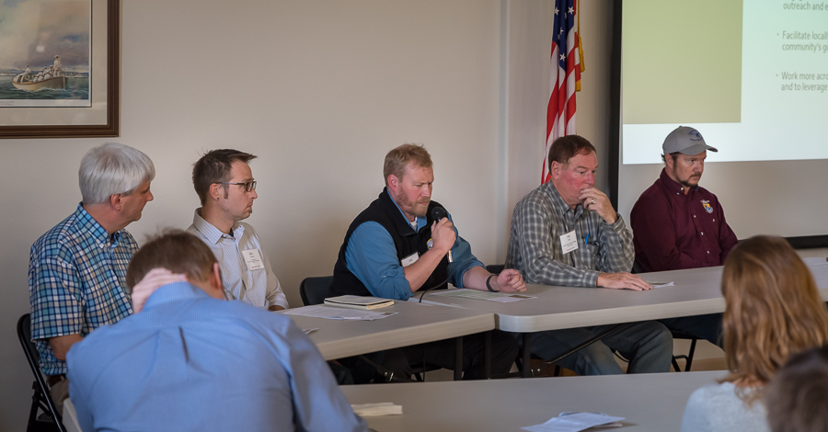

1. What values do you strongly hold for conservation and land management in Southwest Washington?
Figure 11. A very diverse agency panel described a suite of programs and partnerships available to advance working land and conservation interests in the region. Photo credit: John Mankowski.
- Long-term conservation of the region’s natural resources.
- Connected habitat across ownerships.
- Access to outdoors for all people in the region.
- Future generations inherit healthy ecosystems.
- Using a diverse range of approaches to conserve regional biodiversity.
- Collaborative engagement to find common goals and seek solutions.
- Achieving multiple benefits through conservation (i.e., rural economic health and ecological stewardship can go hand-in-hand).
2. How is land use, resource management, and/or conservation important to the quality of life in Southwest Washington?
- Economic benefits of productive and diverse farms and forestlands.
- Outdoor recreation benefits to residents and visitors.
- Aesthetic benefits of living close to working and natural lands.
- Physical and mental well-being benefits of open space.
- Ecological services of healthy environment (e.g., safe and clean water).

3a. What do you see as your primary near-term goals and objectives in managing and conserving land in Southwest Washington?
- Conserve high value habitat (including forest and farmland).
- Manage for healthy forests and reduce wildfire risk.
- Stabilize vulnerable fish and wildlife populations.
- Maintain and enhance quality of life.
- Reduce conversion of working lands to retain environmental benefits.
- Give incentives to family forests/farms that conserve habitat and sustain livelihoods.
- Maintain and improve economic benefits tied to region’s natural resources.
- Build strong agency-landowner partnerships.
- Engage communities on their priorities and not only set our own.
- Build public support for conservation and make it relevant to an urbanizing population.
- Maintain equitable access to public and private lands.
3b. What do you see as your primary long term (50-year outlook) goals and objectives in managing and conserving land in Southwest Washington?
- Good conservation practices on working lands cultivated and passed to the next generation.
- Measurable proof conservation actions are benefitting fish and wildlife.
- Increase resiliency of conservation and working lands to a changing climate.
- A wide range of regional partnerships successfully implementing and achieving their long-range goals, which includes conservation.
- A sustainable and diversified portfolio of science-based land and natural resource management practices.
4a. What are big near-term impediments to managing and/or conserving land in Southwest Washington?
- Invasive plants and animals.
- Fragmentation of working lands, primarily from development.
- Erosion of natural resource industries as land is converted.
- Lack of community will to make long-term conservation investments.
- Competing priorities for limited funding.
- Connection to outdoors in the age of gadgets.
- Challenges articulating conservation in ways meaningful to citizens.
- Lack of relationships and trust among vital stakeholders.

4b. What are big long-term (50-year outlook) impediments to managing and/or conserving land in Southwest Washington?
- More invasive plants and animals.
- Pressure to convert working land to meet housing demands of an even greater population.
- Fewer farm and forestry jobs due to smaller working land base.
- Climate change.
- Possible effect of technology on society’s relationship with the outdoors.
- Fewer dollars for conservation because the public is not as connected to the outdoors.
5. Do you have ideas or suggestions for how to overcome these impediments, particularly through collaborative engagement among stakeholders?
  - Rely more on incentive programs (e.g., Southwest Washington Small Forest Lands Conservation Partnership).
  - Pursue local non-regulatory solutions.
  - Engage more of the community in conservation projects and outreach and education.
  - Facilitate locally-based solutions by gaining a better grasp of community goals and aspirations.
  - Work more across stakeholder groups to see where values overlap and to leverage resources and support each other’s goals.

“If we’re not working the land, we cannot be good stewards.”
~ Agriculture panel representative
“We need to find symbiotic ways to work together.”
~ Small forest landowner panel representative
“We need innovative approaches to commit to long-term conservation. We need to commit to working together in unison.”
~ Agency panel representative
“Stewardship is leaving lands better than we found them. Stewardship also pertains to the communities – our lands surround small towns, and we have a responsibility to provide jobs and help with education.”
~ Large forest landowner panel representative
“We will succeed toward our shared and separate goals when we spend time together and dwell on commonly held values—communities, clean water, clean air, generational forestry, public access, fish and wildlife, and functioning ecosystems.”
~ Conservation panel representative

Crosswalk of Panel Input
Panelist Question #1

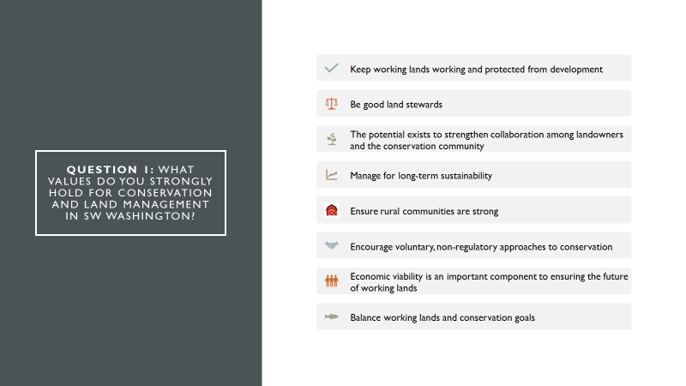
In question one we asked panelists to share the values they strongly hold for conservation and land management in the region. The panels identified a number of closely held values (Figure 4) including a few that stood out because all or most of the panels identified them as values.
Figure 4. Closely held values identified by meeting panelists.

Most panels said they recognize and value the multiple benefits of working lands. Specifically, panelists recognized the benefits of working lands to rural economies along with ecological benefits to fish and wildlife, recreational benefits, as well as ecological services (e.g., water quality).

Another value most groups identified as important is long-term sustainability. Here some respondents spoke of this value in terms of ecological sustainability, such as ensuring that healthy fish and wildlife populations persist over the long-term. Respondents also spoke of sustainability as a need to make sure they can pass along their legacy of viable working lands and opportunity to subsequent generations. Panelists also placed a strong value in making sure they can provide farm and forest products sustainably and over the long-term.

Most groups also placed a high value on being good stewards of the land and holding a strong conservation ethic. This closely links to the values they place on sustainability and their belief that it is important to keep working lands working over the long-term.

Panelist Question #2

In the second question, we asked panelists to characterize the attributes of Southwest Washington that enhance quality of life, particularly with respect to working landscapes. All panel groups noted the importance of working lands and local natural resources as drivers for economic opportunity. One respondent pointed to the importance of this to the region’s quality life because there are no outsized employers like Boeing or Microsoft in the region

Panelists in most groups also noted the role of healthy and productive working landscapes in sustaining a high quality of life. Known for its productive forests, panelists described how working landscapes in Southwest Washington affords a quality of life through the jobs and recreational opportunities it provides to locals and visitors.
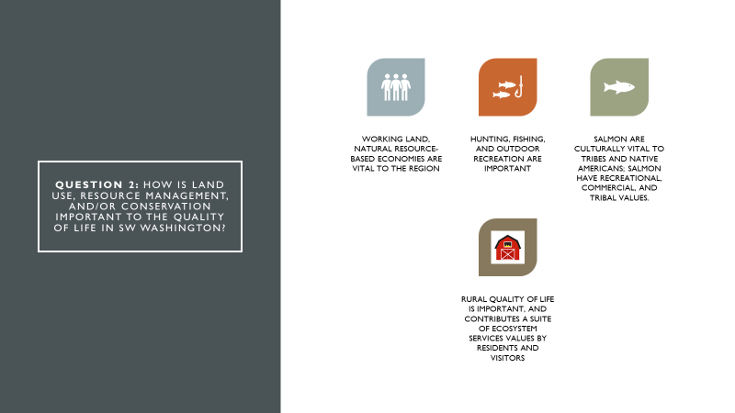
Other important aspects of quality of life that ranked high were the rural feel of the community as well as the recreational opportunities that come with a rural landscape. Figure 5 lists these and other quality of life attributes identified by panelists.
Figure 5 Quality of life attributes that panelists identified as important in southwest Washington.

Panelist Question #3

In question three, we asked panelists to identify their short and long-range goals in conserving or managing working lands in Southwest Washington. All panel groups identified a few of the same goals.

One goal identified by most groups was ensuring that working lands are resilient and healthy. This they mainly presented as a long-term goal for their land management and conservation practices. A number of groups also cited goals to improve messaging so they can build public support and gain better acceptance and trust for what they do. All forestry and agricultural panels also identified economic viability as a goal vital to their business operations.

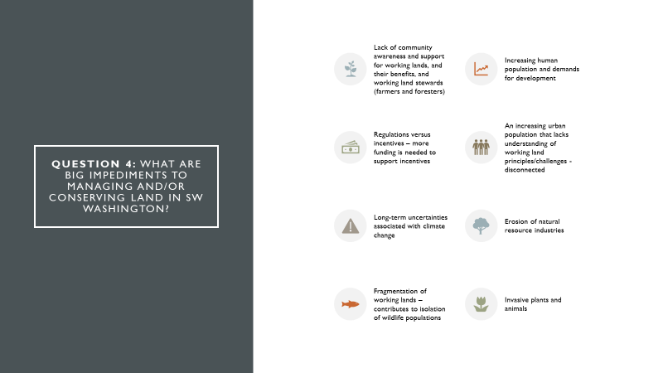
Panelist Question #4
Figure 6. Some of the challenges that panelists said they face now or in the future.

In question four, we asked panelists to identify the short and long-range challenges in conserving or managing working lands in Southwest Washington. Most panels identified the pressures of development to meet the demands of a growing Southwest Washington population. Specifically they highlighted challenges of development such as the potential for it to erode the region’s natural resource industries as well as its effect of fragmenting habitat.

All the panels pointed to the challenges that comes from stakeholder distrust. Many described this mistrust as rooted in ineffective communication and a lack of awareness of the values of different members of the community. A number of the panels pointed to how this sometimes has led to litigation, which further drives the cycle of distrust.

All forestry and agricultural panels also identified the uncertainty and increasing burden of regulations as a challenge to their businesses. A number of the panels also describes the challenge of doing conservation with little or no funding. Figure 6 lists these and other challenges that panelists said they face now or in the future.

Panelist Question #5

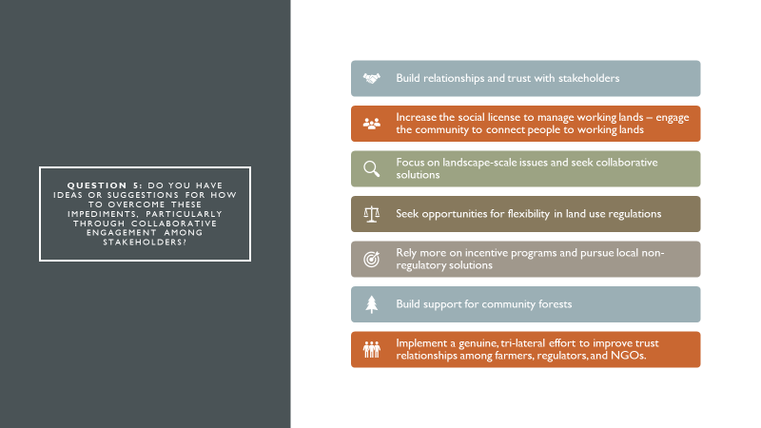
In question five panelists shared ideas for how to overcome the challenges they face (Figure 7). Many of the ideas came under the umbrellas of collaboration and coalition building, which is necessary to address a major stated challenge of theirs, which is a lack of understanding and trust from different stakeholders and members of the community. Related to moving beyond mistrusts and misunderstanding were a number of suggestions and ideas for doing more public outreach and education.
Figure 7. Excerpt of some of the panelist’s ideas for addressing the challenges they face in managing and conserving working lands.

All groups understood that there are many ways to get good conservation happening on the ground. Thus the panelists provided suggestions and their perspectives on approaches that rely on incentives based programs as well as potential innovations and flexibilities in the design and implementation of regulations.

Breakout Sessions
Meeting attendees convened in five breakout sessions to discuss in greater detail the information provided during the panel presentations, and to specifically address the following questions:
- What are the near-term and long-term challenges and stressors to working lands and habitat conservation goals and values in Southwest Washington?
- What near-term and long-term strategies, tools, programs, and partnerships would allow regional stakeholders to achieve goals in the context of key stressors and challenges to working lands and wildlife in Southwest Washington?

Near-term challenges and stressors
Meeting attendees described near-term challenges and stressors in six primary areas— communication/people, land ownership/management, funding, regulations, infrastructure, and conservation issues.

Communication/People
The breakout groups spoke of numerous near-term people/communication challenges, such as maintaining an adequate labor force, incentivizing multi-generational stewardship, removing barriers to entry in agriculture, and tackling the factors that lead to poverty and that lower the quality of life in rural areas.

Land ownership/management
The incentive to convert working forests and farms to development was a common theme among breakout sessions. This often happens when landowners sell off land they no longer can afford or when subdividing for development becomes too lucrative an opportunity to pass up. Forest landowners and farmers often also subdivide when passing their estate to their heirs. This happens when their children are not interested in working the land or when there are too few incentives for children to continue in their parents’ footsteps.

Competing uses of land, land fragmentation, and land mergers also place pressures on forest and agricultural landowners. Many areas with replanted trees go unmanaged, putting these and adjacent lands at greater risk of disturbances like disease and forest wildfires. Forest landowners and farmers in Southwest Washington also face the mounting pressures of development encroaching their lands. Keeping landowners solvent under these circumstances is challenging.

Funding
Lack of funding exists for assistance and incentive programs, management practices, conservation programs, and forest health.

Regulations
Breakout groups say they face a lack of regulatory certainty as well as a lack of flexibility to implement land use regulations. They also noted that regulations are sometimes inconsistently applied, are redundant, confusing, complex, or outdated. Too much regulation creates an incentive to develop rather than maintain working forests and farmlands. Some breakout groups had specific problems with the Growth Management Act that they said require further discussion and creative solutions. They also cited the uncertainties they face with potential exposure of their businesses to future ESA listings.

Infrastructure
A sustainable forestry and agricultural industry in Southwest Washington requires adequate infrastructure.
To stem the loss of mills and agriculture processing plants and other facilities requires proactive and diversified strategies. This includes designing facilities to reduce future impacts (e.g., address stormwater in current infrastructure development), making sure local rural communities have the amenities to attract and retain people, and ensuring opportunities for employment through training and education as manual labor jobs shifts with more automation.

Conservation Issues
Conservation challenges to managing working lands included:
- Ineffective conservation strategies – goals, need, benchmarks – to track progress and make wise investments;
- Ineffective ecosystem services programs (how to quantify services);
- Diminished economic potential when transferring lands from farm and forest production to conservation;
- Impacts and effects of climate change;
- Issues of water and hydrology such as water use, water quality, and flood retention;
- Wildlife damage; and
- Wildlife and habitat connectivity (e.g., highway crossings).

Long-term challenges and stressors
Long-term challenges and stressors focused on people, climate change effects, land-related topics, funding/market/infrastructure stressors, and conservation issues.

People
Breakout groups cited the long-term challenges of maintaining working lands alongside a growing population. These include the needs for social services, which will increase if opportunity declines in rural communities. Another cited challenge is the possibility that rural communities get left behind as investment goes towards burgeoning urban and suburban communities. The fact that rural communities do not have the resources of urban communities affects their long-term resilience and viability. Resources that rural communities will need include adequate technical assistance so small landowners can take advantage of incentives to implement conservation measures. Breakout groups also noted that as populations grow, so will the demands for adequate of water quantity/quality between urban residents and farm/forest producers.

Climate Change Effects
These were cited as long-term challenges related to climate change:
- Warmer and wetter winters (and associated pest and disease issues);
- Heat stress during summer;
- Altered fire regimes;
- Shifts in crop production;
- Potential influences of climate change on habitat connectivity;
- Uncertain of tree species and varieties that will be adaptable and resilient to climate change; and
- Increased listings of endangered species, especially those that cannot adapt to climate change.

Land-related
These were cited as long-term land-related challenges:
- Land conversion and fragmentation;
- Limited financial access to purchase land; and
- Physical access to land for recreation.

Funding, Markets, and Infrastructure
- Changing markets that promote substitutions for wood products;
- Shifts in demographics that reduced income for fish and wildlife agencies (fewer hunting and fishing license sales); and
- Movement of goods and services and how this affects community sustainability.

Conservation
Issues associated with wildlife populations and the best to use of limited resources to promote connectivity was identified as a challenge.

Solutions That Address Near-Term Challenges

People and Community
- Using diverse approaches to build relationships and trust, including field trips and public awareness/education, volunteer opportunities, and opportunities for job shadowing;
- Develop marketing campaign with consistent messaging that promotes mutual advocacy, a shared vision, successful outcomes, and a sustainable infrastructure for collaboration;
- Create opportunities for sustained dialogues and small group discussions that seek solutions through non-political approaches;
- Connect with elected officials and build relationships;
- Expand the social license to manage lands;
- Promote working lands by promoting directly to consumers(e.g., farmer’s markets); and
- Create incentives for people to live in urban areas (e.g., creative developments, clustered subdivisions, high-density developments) to conserve lands as populations grow.

Lands
- Use incentives to minimize conversion of valuable working lands (e.g., tax breaks, land trust programs, payment for ecosystem services);
- Research and communication into the profitability of small forests and farms;
- Monetizing secondary values of working lands;
- Update zoning regulations;
- Preventing sprawl through smart growth planning;
- Develop approaches to identify and evaluate perceptions around working lands conservation solutions (social science);
- Establish programs that support conservation and ecosystem services buy-ins, forest legacies, fish passage on family forests, and other incentive programs;
- Adequately fund existing programs that support private land ownership and working lands;
- Promote opportunities to establish community forests, supported by local decision making; and
- Address non-point source pollution and advance water quality improvements through nutrient trading credits (e.g., Willamette Partnership) and green stormwater infrastructure.

Funding and Capacity
- Create and maintain local sources of conservation funding, and ensure the infrastructure and capacity exists to forecast and adapt to changing and diverse markets;
- Support a diversity of grant programs, ensuring programs are adequate to address the scale of the issues;
- Adjust tax policy to support working lands, and re-empower conservancy boards to address water issues;
- Increase training opportunities for landowners, including considering replicating the Northwest Agricultural Business Center in Southwest Washington; and
- Consider cross-watershed scaling of incentives to add flexibility in programs and incentives to allow more access to those programs.

Solutions That Address Long-Term Challenges

Climate Change
- Develop a collaborative community climate resilient strategy among all stakeholders;
- Conduct risk assessments, including maps of who inherits disproportionate amount of risk;
- Develop adaptation actions/strategies (e.g., green stormwater infrastructure) and develop response options to address climate risks;
- Promote using local products (less transportation/carbon impact); and
- Test seed zones to assess tolerance of local species to drought and high temperatures.

Development and Population
- Promote sustainable development and cities as livable and attractive places;
- Focus growth to urban growth areas by encouraging flexible regulations/zoning;
- Increase educational opportunities to span the rural-urban divide;
- Take a long-range view for land use planning;
- Address fragmentation through land use planning;
- Create opportunities and programs for next generation to gain farm experience;
- Address single family exemption for shoreline development;
- Regularly inform decision-makers about importance of high priority issues and policies;
- Coordinate highway crossings and infrastructure with needs for fish and wildlife habitat;
- Raise political will for growth management; and
- Implement outreach and education that focuses on shared values and outcomes.

Funding, Markets and Capacity
- Explore sustainable and wise uses for taxpayer dollars;
- Reforms inheritance taxes to support multigenerational agriculture and forestry;
- Investigate putting a dollar value on ecosystem services;
- Create effective carbon markets and use carbon pricing to increase incentive value;
- Increase capacity of conservation community to hold easements for local development;
- Invest in government funding and easements as a surrogate for active land management;
- Create and diversify local markets and product lines;
- Assist small communities in marketing their products (e.g., regional cooperatives to promote Willamette Valley Pinot Noir);
- Establish and promote tools for technical and financial assistance;
- Establish and implement conservation futures programs;
- Establish workable transfer and/or purchase of development rights programs;
- Develop a Conservation Reserve Enhancement Program;
- Establish a Voluntary Stewardship Program;
- Stimulate good neighbor authority;
- Establish Joint Chiefs’ forestry partnership;
- Foster incentives to new producers in underserved communities; and
- Promote novel and flexibility incentives to leave options open for new industry and new future uses, such as term leases instead of permanent easements.

Regulations
- Demystify water regulations, address and increase awareness in water rights issues by communication about the issue and placing water rights in a trust; and
- Develop results-based regulations that advance desired outcomes and incorporate adaptive management.

List of Attendees (workshop and field trip)
Bob | Amrine | District Manager | Lewis Conservation District
Hilary | Aten | Conservation & Stewardship Director | PCC Farmland Trust
Jeff | Azerrad | Environmental Planner | Washington Department of Fish and Wildlife
Susan | Bakke |  | Great Old Broads for Wilderness
Colin | Barricklow | Owner/Farmer | Kirsop Farm
Trina | Bayard | Director of Bird Conservation | Audubon Washington
John | Bolender | District Manager | Mason Conservation District
Amy | Boyd | Forest Land Steward | Cowlitz Indian Tribe
Nicole | Budine | Policy and Campaign Manager | Cascade Forest Conservancy
Samantha | Bussan | Graduate student | Washington State University Vancouver
Nicholas | Carr | Chehalis Basin Director | Forterra
Hannah | Clark | Regional Director | American Farmland Trust
Fred | Colvin | Cattle Rancher | Colvin Ranch
Annie | Cubberly | Broad Band Leader | Great Old broads for Wilderness
Lisa | DeBruyckere | President | Creative Resource Strategies, LLC
Kate | Delavan | Conservation Manager | PCC Farmland Trust
Bill | Dewey | Director of Public Affairs | Taylor Shellfish
Ben | Donatelle | Policy Specialist | Washington Recreation and Conservation Office
Hannah | Dondy-Kaplan | Fish and Wildlife Project Administrator | Bonneville Power Administration
Heather | Druffel | Policy and Engagement Specialist | Hancock Forest Management
Patrick | Dunn | Program Director | Center for Natural Lands Management
Caprice | Fasano | TFW Fish Habitat Biologist | Quinault Indian Nation
Kirsten | Feifel | Habitat Policy | Washington State Department of Natural Resources
Hilary | Franz | Commissioner of Public Lands | Washington State Department of Natural Resources
Phil | Gardner | District Director | Office of Congressman Denny Heck
Libby | Gier | Environmental Planner | Washington Department of Natural Resources
Kevin | Godbout | Dir. of External and Regulatory Affairs | Weyerhaeuser
Jay | Gordon | Executive Director | Washington State Dairy Federation
Greg | Green | Manager - Conservation Programs | Ducks Unlimited
Joshua | Halofsky | Natural Resource Scientist | Washington State Department of Natural Resources
Shaun | Hamilton | Project Manager | Western Rivers Conservancy
Heidi | Haserot | Realty Specialist | Bonneville Power Administration
Amy | Hatch-Winecka | Deputy Director | Thurston Conservation District
Jessica | Helsley | Washington Senior Program Manager | Wild Salmon Center
John | Henrikson | Wild Thyme Farm | Washington Farm Forestry Association
Doug | Hooks | Forest Policy | Washington Forest Protection Association
Dave | Howe | Habitat Program Manager | Washington Department of Fish and Wildlife
Joanna | Kaiserman | Land Use Planner | Columbia River Gorge Commission
Jason | Karnezis | Fish and Wildlife Project Manager | Bonneville Power Administration
Cyndi | Karp | Ecosystem Advocate | Volunteer
Cherie | Kearney | Forest Conservation Director | Columbia Land Trust
Brian | Kittler | Director, Western Regional Office | Pinchot Institute for Conservation
Robb | Krehbiel | Northwest Representative | Defenders of Wildlife
Meade | Krosby | Senior Scientist, Climate Impacts Group | University of Washington
Mike | Kuttel Jr. | Farm Bill Coordinator | Washington Department of Fish and Wildlife
Chris | Lapp | Refuge Project Leader | Ridgefield National Wildlife Refuge Complex
Pat | Lee | Legacy Lands Program Manager | Clark County
Dale | Lewis | District Issue Work Director | Congresswoman Jaime Herrera Beutler
Teresa | Lou | Manager | Port Blakely Tree Farm
Rachel | Maggi | Area Biologist | Natural Resources Conservation Service
Christine | Mahler | Executive Director | Washington Wildlife and Recreation Coalition
Lindsay | Malone | Director of Programs | Northwest Natural Resource Group
Nicole | Maness | Resilient Habitat Program Manager | Willamette Partnership
John | Mankowski | Coordinator | PNW Coast LCD
Nellie | McAdams | Program Director | Farm Preservation
Kelly | McAllister | Fish and Wildlife Program Manager | Washington Department of Transportation
Emelie | McKain | Chehalis ASRP Project Manager | Washington Department of Fish and Wildlife
Lydia | Mendoza | Conservation Lead | Columbia Land Trust
Thomas | Miewald | Science Applications | US Fish and Wildlife Service
Tammi | Miketa | Manager, Small Forest Landowner Office | Washington State Department of Natural Resources
Adrian | Miller | Director of Administration and Corporate Affairs | Pope Resources
Kenneth | Miller | SFLO Activist | WFFA, WFPA, FFF, FFL, TFW Policy
Sarah | Moorehead | Interim Executive Director | Thurston Conservation District
Christine | Myers | Tribal Planner | Cowlitz Indian Tribe
Michael | Nordin | District Manager | Pacific and Grays Harbor Conservation Districts
Jarod | Norton | Project Manager | U.S. Army Corps of Engineers
Elaine | O'Neil | Executive Director | Washington Farm Forestry Association
Kristeen | Penrod | Director | SC Wildlands
Jim | Peters | Habitat Policy Analyst | Northwest Indian Fisheries Commission
John | Peters | Environmental Engineer | Regenerative Development Partners
Matt | Provencher | Stewardship/Technical Assist. Forester | Washington State Department of Natural Resources
Jordan | Rash | Senior Conservation Director | Forterra
Angie | Reseland | Coordinator/Executive Director | Necanicum Watershed Council
Larissa | Ritzman | Natural Resources Director | Shoalwater Bay Tribe
Betsy | Robblee | Program and Operations Associate | Washington Wildlife and Recreation Coalition
Luke | Rogers | Research Scientist | University of Washington
Shavonne | Sargent | Certified Forester | Consultant
Cheryl | Schultz | Associate Professor | Washington State University Vancouver
Patrick | Shults | Extension Forester | Washington State University Extension
Court | Stanley | President, Forestry Division | Port Blakely Tree Farm
Brian | Stewart | Habitat Connectivity intern/volunteer | Washington Department of Transportation
Paula | Swedeen | Policy Director | Conservation Northwest
Jeff | Swotek | Resource Conservationist | Natural Resources Conservation Service
Dean | Takko | Senator | Washington State Senate
Patricia | Townsend | Regional Extension Specialist | Washington State University
Stu | Trefry | Southwest Washington Regional Manager | Washington State Conservation Commission
Kelly | Verd | Special Projects Coordinator | Lewis Conservation District
Anthony | Waldrop | Watershed Resources Specialist | Grays Harbor Conservation District
Andrea | Watts | Tree Farm Owner | Tree Farm Owner
Max | Webster | Evergreen Forests Program Manager | Washington Environmental Council
Kate | Wells | Section Chief Environmental Planning | U.S. Army Corps of Engineers
Ellen | Wilt | Fish and Wildlife Biologist | Bonneville Power Administration
Eric | Wisch | Pacific Cascade Region Manager | Washington State Department of Natural Resources
Ryan | Wysocki | Resource Conservationist | Natural Resources Conservation Service
Leonard | Young | Strategic Advisor | Washington State Department of Natural Resources

